**Manyu Elements and Cultural Association (MECA) Montreal**

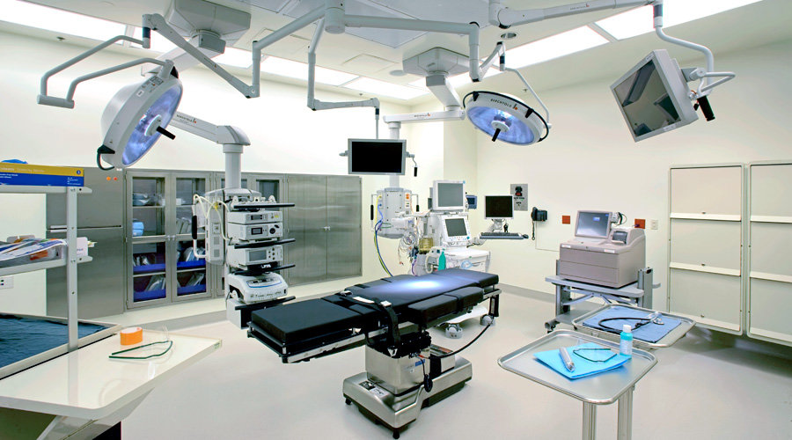

**10th anniversary IMPACT PROJECT draft.**

**Introduction of project owner**

Manyu Elements and Cultural Association (MECA) Montreal was founded in July of 2007. The association unites sons and daughters of Manyu Division, in the South West Region of Cameroon, residing in Montreal and its environs. The aims of the association include (i) to expose the rich cultural diversity of the Manyu people in Canada and the world at large; (ii) to be of moral assistance to one another as brethren of a common ancestry; (iii) to organize cultural activities as a gear to unite the Manyu people, thus reminding them of their strong cultural attachment; (iv) to educate and raise awareness amongst its members and the general Cameroonian, Canadian, North American public about Manyu Division of the Republic of Cameroon; (v) to support or sponsor developmental projects in Manyu Division, South West Region of Cameroon.

Members of MECA meet on the first Saturday of the month to discuss, plan and implement activities guided by the above aims. Locally, we are actively involved in cultural and environmental events in Montreal. As concerns developmental projects in Manyu Division, MECA Montreal has offered books and other educational materials to schools in Bache, Besongabang, Tinto and Ebeagwa. In 2015, 100 benches and didactic materials were donated to five schools randomly selected in Akwaya and Eyumojock sub-divisions. Our most recent developmental project was the significant financial support to the Barah road Project in Upper Baying sub-division. MECA intends to carry out a major project in the healthcare sector during her 10th anniversary celebrations in 2017.

**Background and relevance of project**

Cameroon is a sub-Saharan African (SSA) country with an estimated population of 21.7 million. Administratively, the country is partitioned into ten Regions. Each Region is further divided into Divisions. There is 58 Divisions. English and French are the official languages.

The country has a weak healthcare system and ranked 152 among 187 nations[1]. Average life expectancy is 56years and the Maternal Mortality Rate of, 667/100,000 live births, is one of the highest in Sub-Saharan Africa. There is a shortage of healthcare providers with one doctor per 13,000 inhabitants. Inadequate financing of the healthcare system is depicted by the state of the infrastructure and equipment in most public healthcare facilities that serves the majority of the population. Furthermore, government contributes only 31% of the healthcare cost per individual **(ref).** The patient and family cover the remainder of treatment costs usually through out-of-pocket payments.

**Healthcare in Manyu Division**

Manyu Division has an estimated population of 177, 389, majority of whom are peasant farmers. The government provides healthcare services to this population through one General Hospital and several smaller health facilities. The hospital has the following departments: Medicine; Surgery; Radiology; Obstetrics and Gynecology; Maternity; Paediatrics; Dentistry; Laboratory, Pharmacy and Mortuary. However, some of the departments are non-functional due to lack of basic medical equipment. This deficiency in working tools affects the quality healthcare services. Further, specialist physicians are not motivated to work in this hospital due to the lack of equipment.

**Project Goal**

The goal of Impact Project is to improve the quality of healthcare services to the population of Manyu Division. Although the primary target of the project is to upgrade the surgical room of the Mamfe General hospital, we will acquire medical supplies needed in other departments and health facilities. We are mindful of the fact that having the right working tools alone will not translate to improved quality of care.

**Planned activities**

The project is conceptualized in four phases.

**Phase I: Planning (September 2016 to May/June, 2017)**

During this period, we will elaborate on the details of the project: start communication with a potential supplier, identify and contact potential sponsors, publicize the project and work towards obtaining the required documents from the Cameroon government.

In the meantime, we have contacted MedShare, a US-based non-profit organization with expertise in the supply of medical equipment to Africa. Our understanding is that they have done business in Cameroon in the past. According to MedShare, the approximate cost for a 40ft container of medical supplies and equipment is 25, 000 USD$. This cost includes shipment to the port of the receiving country. Please contact MedShare website: [www.medshare.com](http://www.medshare.com) for more information.

We will continue to work with MedShare and our partners in Cameroon to get details of the supply. The Chief Medical officer for Manyu Division and the medical director of the Mamfe General Hospital will help us to identify needed medical supplies and appropriate equipment. In addition, MECA will continue to explore and develop partnerships with potential sponsors for this project.

**Phase II (Acquisition) July 2017-April 2018**

During this period, we plan to raise the complete amount for the project and finalize our order from the supplier. We anticipate raising the bulk of the money during the 10th anniversary celebration in May/June 2017. The funds available after this event will determine how fast we can proceed with the next steps.

**Phase III- Clearing, distribution/reception and installation (May- December 2018)**

We expect the container to arrive the port of Douala from where it will be cleared and forwarded to Manyu Division. A needs-based assessment will inform the distribution of the equipment and materials. This procedure will involve relevant stakeholders

**Phase IV Evaluation**

To assess the effect of our project, we plan to conduct a pre- and post-implementation survey involving healthcare workers of beneficiary facilities and service users. The exact design of this survey will be elaborated in due course.

**Budget**

A detailed budget for this project has been prepared by the committee in charge and we are expected to raise a minimum of CAD 35,000 in other to achieve success in this project. Details will be provided to all stake holders in due course. We anticipate raising the bulk of the finances for this project during the 10th anniversary celebration in May/June 2017. This will come in various forms: member contributions; fund-raising during the anniversary gala; sale of anniversary souvenirs; and donations from other elites, cooperate bodies, and good people like.

**Stakeholder analysis**

|  |  |  |
| --- | --- | --- |
| **Name** | **Role** | **Comments** |
| MECA Montreal | Project owner; Supportive | Members will contribute their time, competences and money |
| Sister MECA associations in North America | Supportive | To provide moral and financial support |
| Cameroon High Commission in Ottawa | Supportive | To facilitate logistics and clearing of container from the Douala port; Financial assistance |
| Partner cultural associations in Montreal | Supportive | To provide moral, intellectual and financial support |
| Chief launcher | Supportive | To facilitate obtaining of relevant documents from the Cameroon government and financial support |
| Individual and cooperate sponsors organizations & | Supportive | Technical, logistic and financial support |
| Cameroon Customs service | Challenge | In case we are unable to obtain an executive order to exonerate custom duties, we must explore ways to pay only the due fees. |
|  |  |  |

**Expected outcomes**

*Although it is difficult to determine the outcome of a project of this nature due the complex interplay of factors involved, we are hopeful of the following outcomes:*

*(i) Quality of care:* Making available medical equipment and materials can improve the efficiency of healthcare providers and result in better quality of healthcare;

*(ii) Saving of lives:* Proper use of medical equipment by skilled personnel has the potential to save lives for patients in critical conditions;

*(iii) Improved access to healthcare*: By providing health facilities with medical equipment and materials, the fees charged patients services are likely to decrease. This will enable more people to have access to services they would otherwise not be able to afford; and

(iv) *Retention of healthcare providers*: Healthcare providers, especially specialist physicians, can be motivated to live and work in Manyu Division if provided with the necessary tools.

**10th Anniversary Project Committee Chair: Fonderson Tataw Ashu**

**Medical Project Sub Committee Chair: Mark Tambe keboa**

**Fund Raising Sub Committee Chair: Valentine Eyong**

[10years@mecamontreal.com](mailto:10years@mecamontreal.com)

[www.mecamontreal.com](http://www.mecamontreal.com)

1. According to the UN Human Development Report 2014.